Mark Kardash

29 August 2023

SDEV350 6380

Professor Carl Eyler

Note: For easier program creation, I have done ONE GENERAL TEST of the program, instead of testing the steps one at a time. Hope that makes sense.

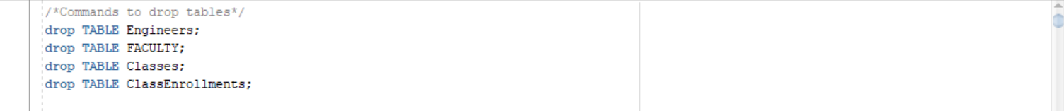

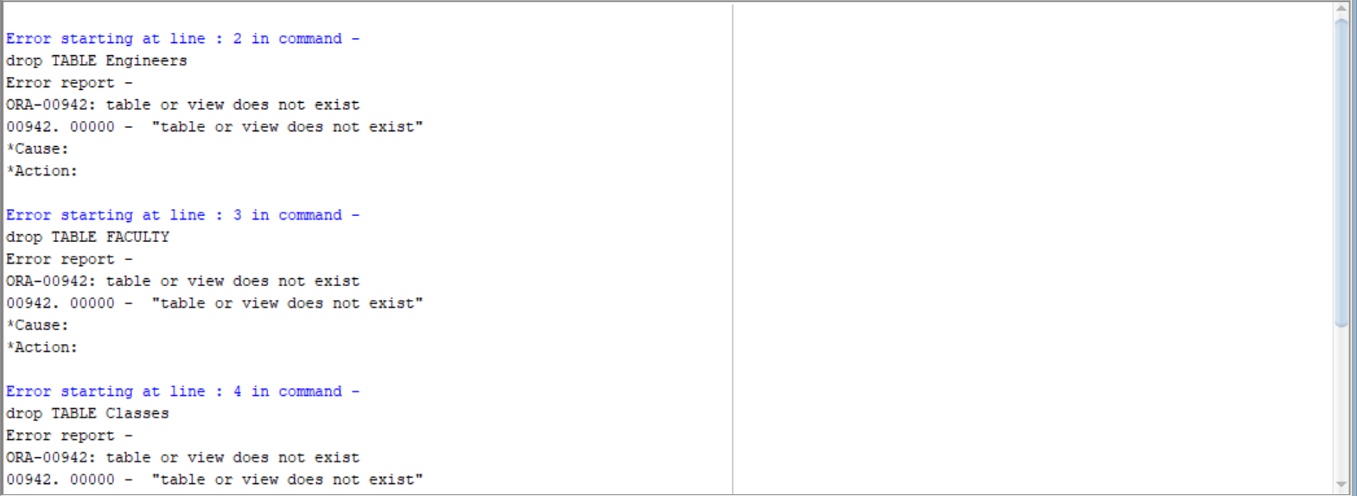

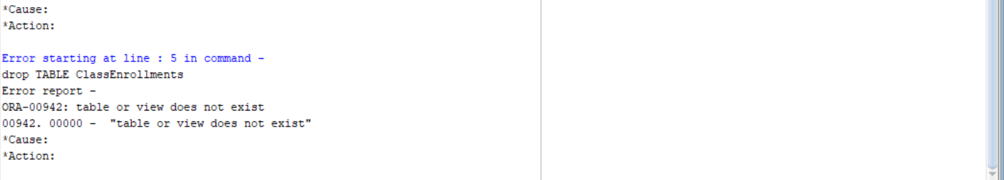

Figures 1a, 1b and 1c: Dropping Tables

The two figures above show the successful completion of Step 1, that is, dropping the tables. Since We have not yet created any tables, it is natural for us to get an error.

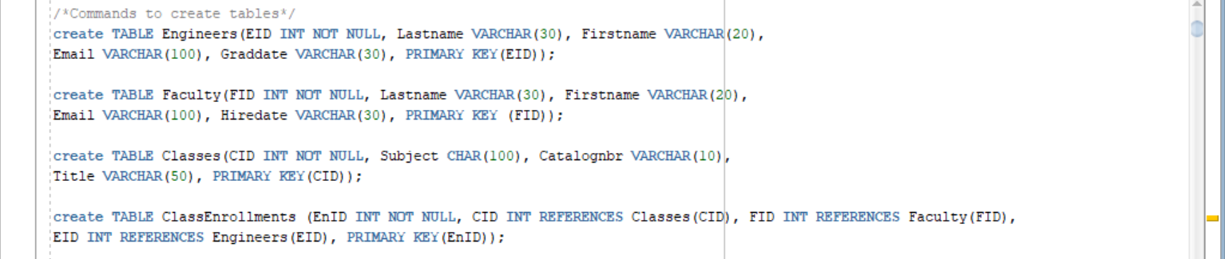

Figure 2a: Creating Tables Code

The above image demonstrates the code written to create the tables required.

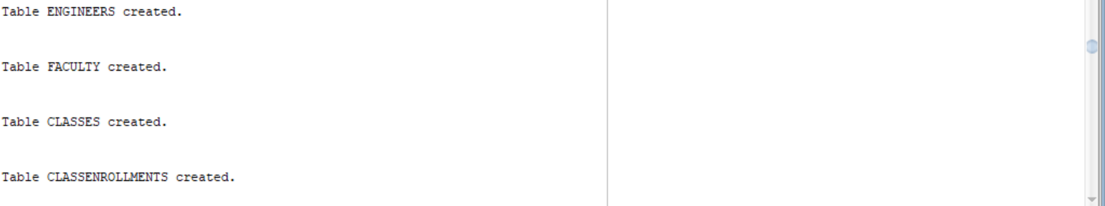

Figure 2b: Creating Tables Result

In the above figure, all 4 of the requested tables have been created successfully, as indicated by the environment, thus completing Step 2.

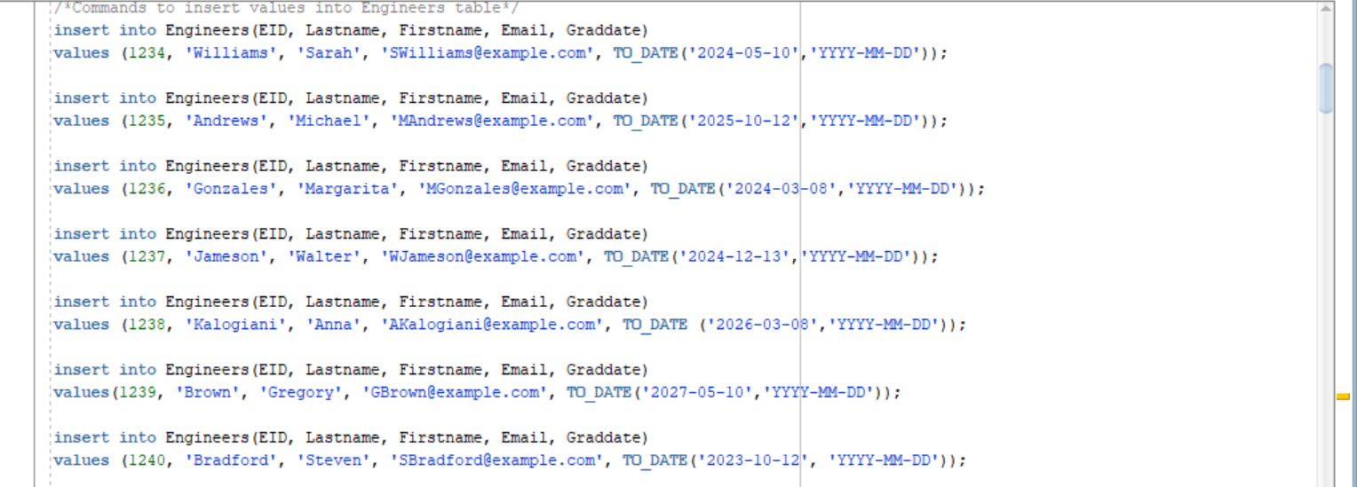

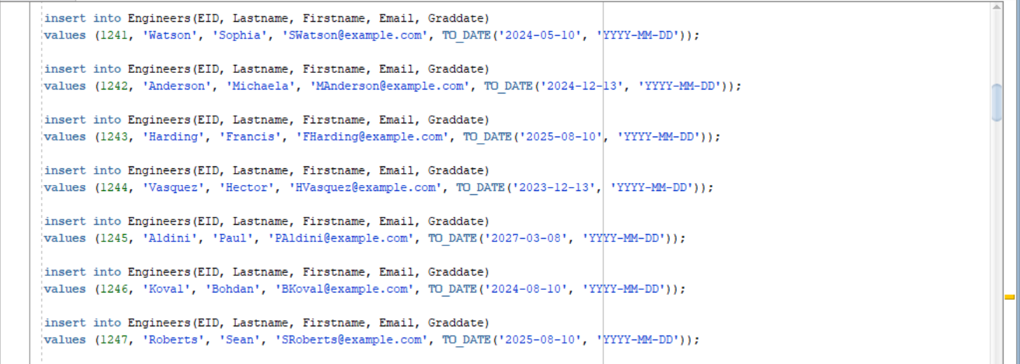



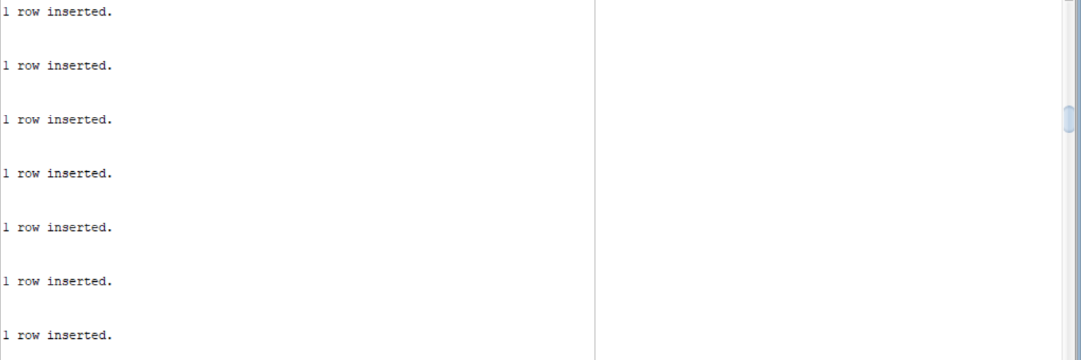

Figures 3a, 3b, 3c, 3d: Inserting values into Engineers Table

The above figures demonstrate the insertion of records into the Engineer Table. This gives a successful result, with all values inserted (Number of records can be checked in files).

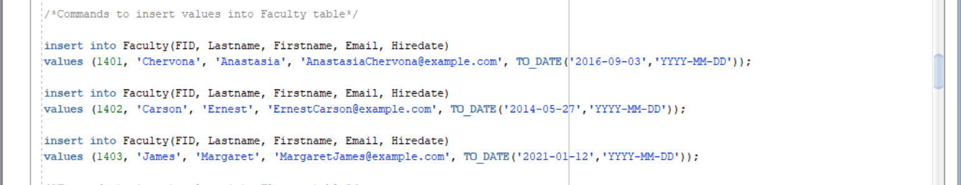

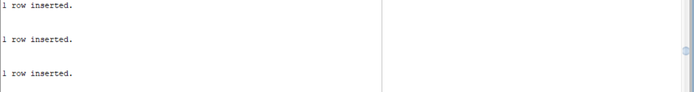

Figures 4a, 4b: Inserting Values into Faculty table.

The above images show the successful insertion of three (3) records into the newly created Faculty table.

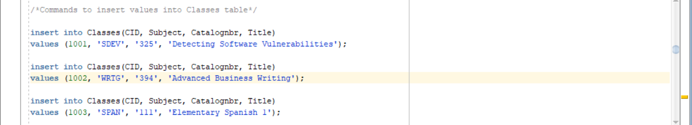

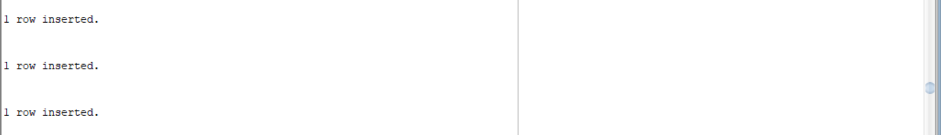

Figures 5a, 5b: Inserting Values into Classes table

The above images show the successful insertion of three (3) records into the newly created Classes table.

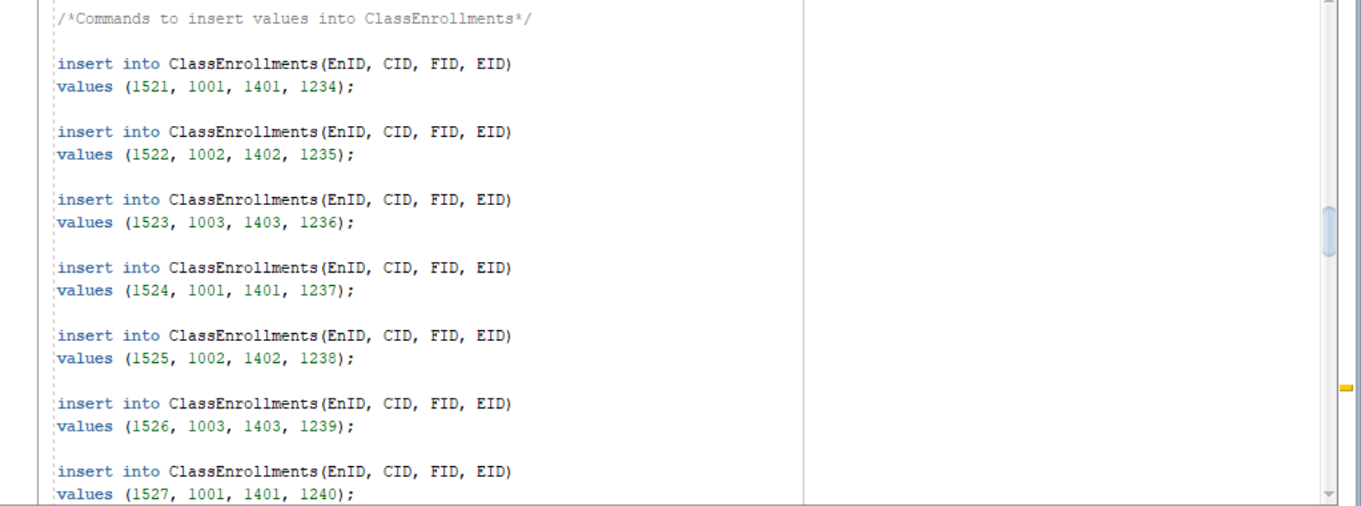

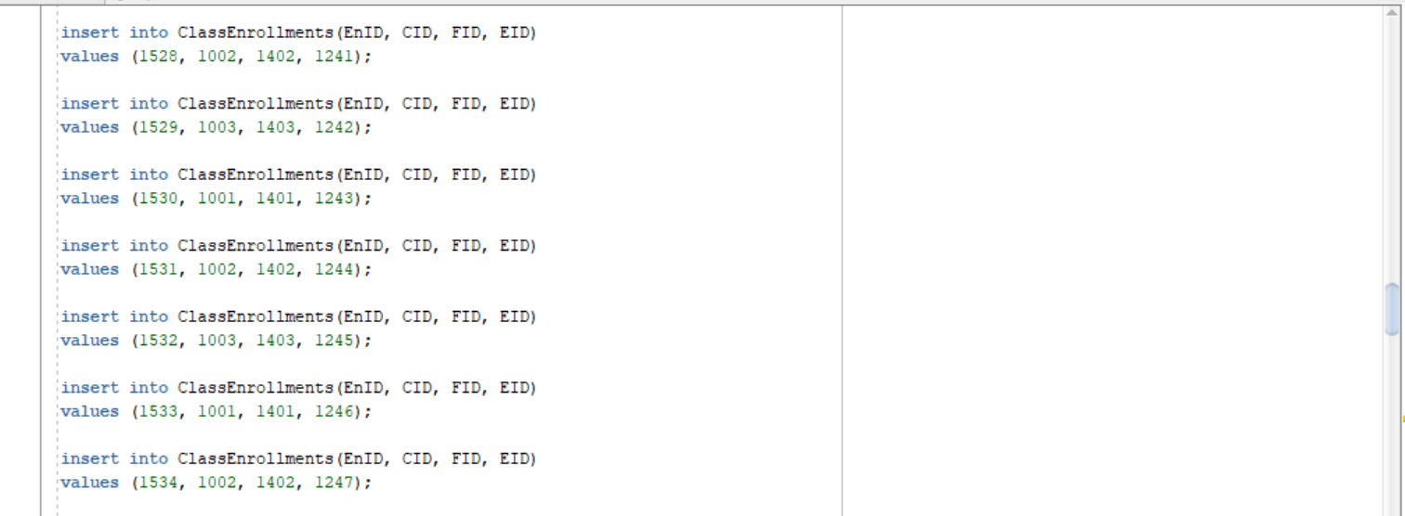

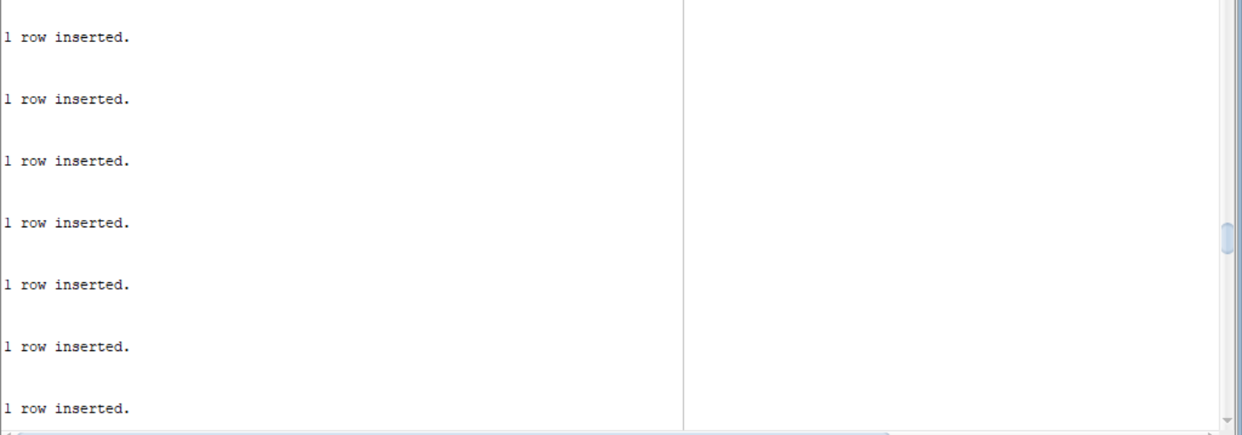

Figures 6a, 6b, 6c, 6d: Inserting Values into ClassEnrollments table.

The above figures demonstrate the insertion of records into the ClassEnrollments Table. The result is success, therefore completing Step 3. (Number of records can be checked in files).

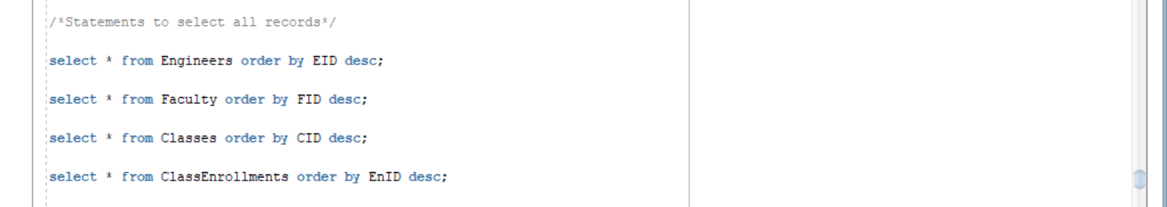

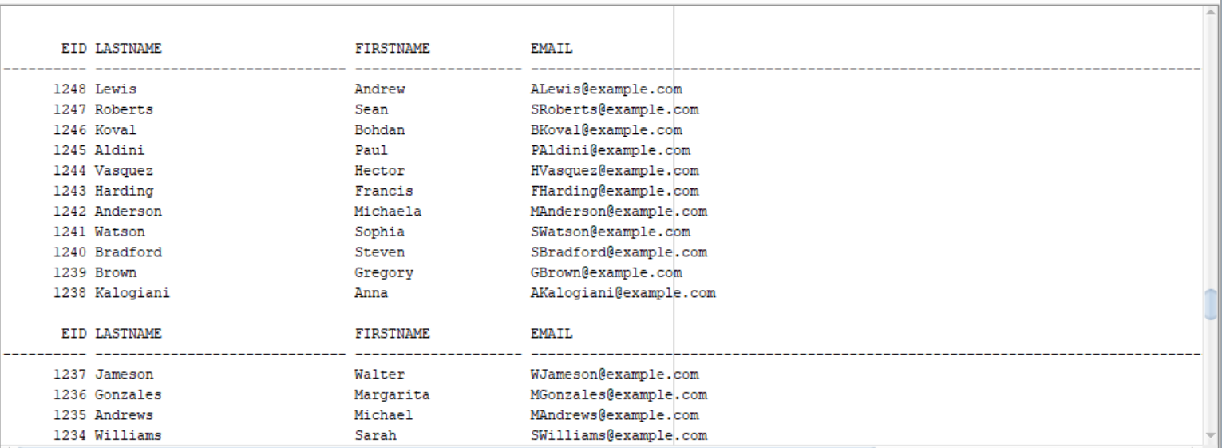

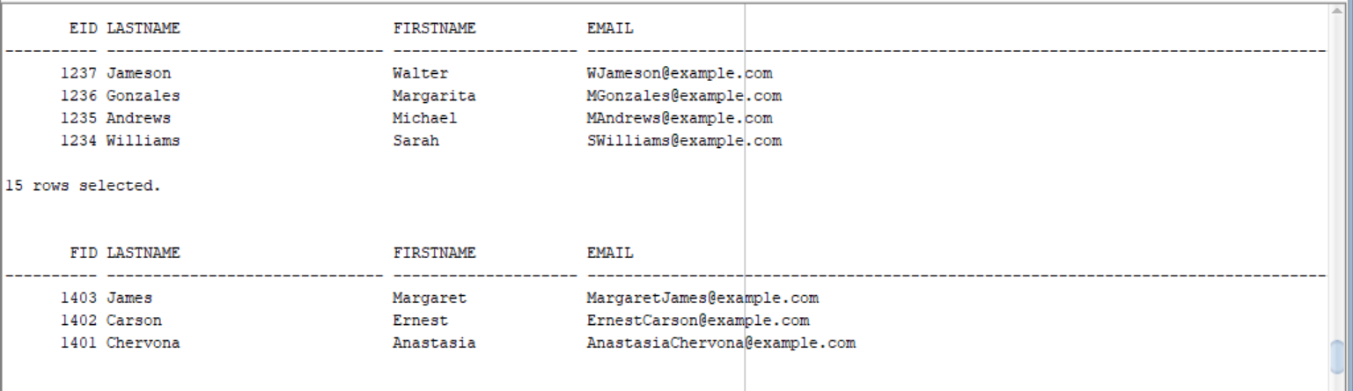

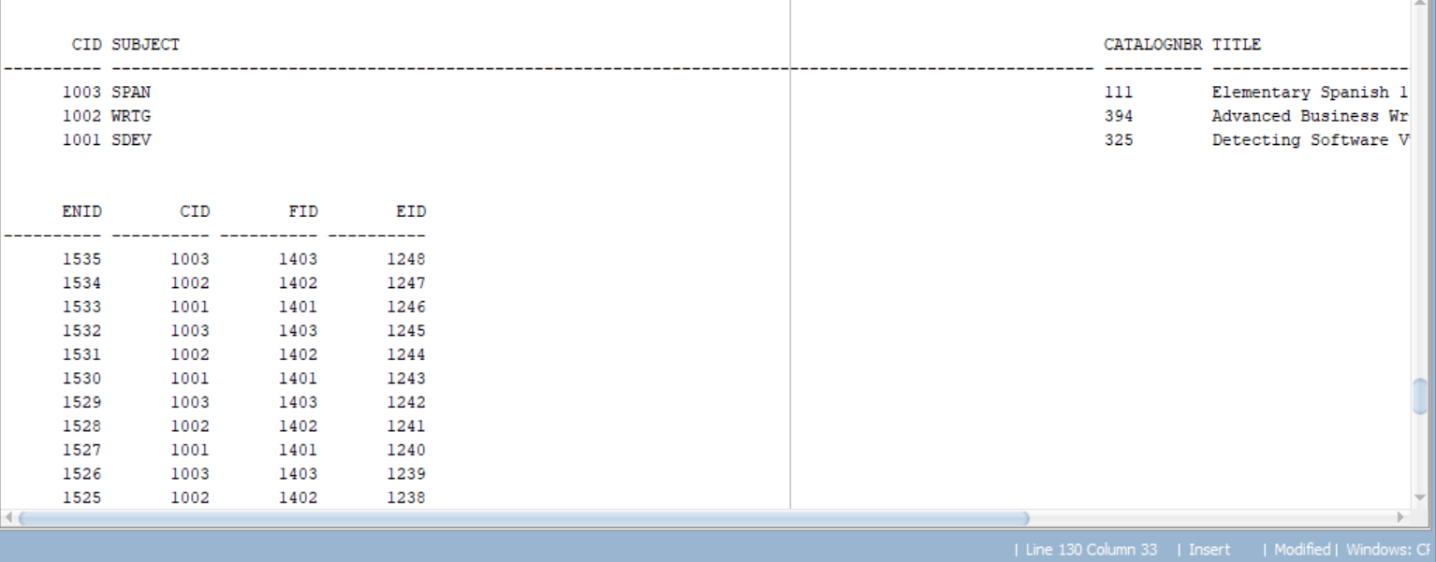

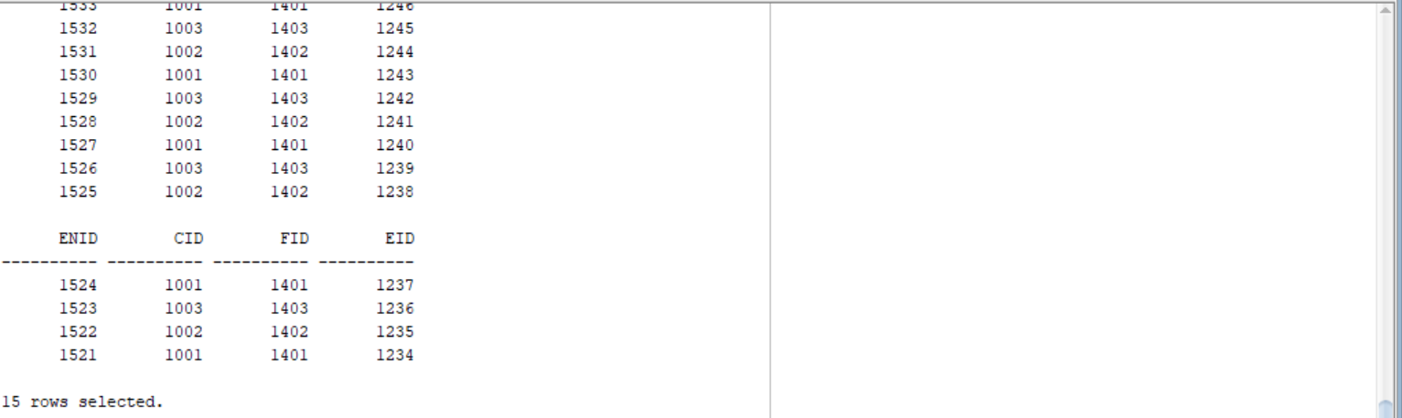

Figures 7a, 7b, 7c, 7d, 7e: Selecting all records.

The figures above show the successful demonstration of all records requested, and therefore the completion of Step 4.

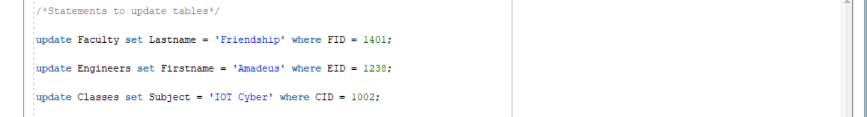

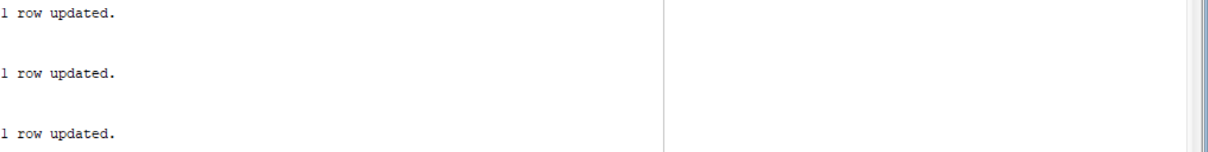

Figures 8a, 8b: Updating Rows

These figures show the code and result of updating rows with new data. Since all three (3) rows are now updated, Step 5 is a success.





Figures 9a, 9b: Deleting a row.

Here, we see the code and result for deleting the row with the smallest EnID.

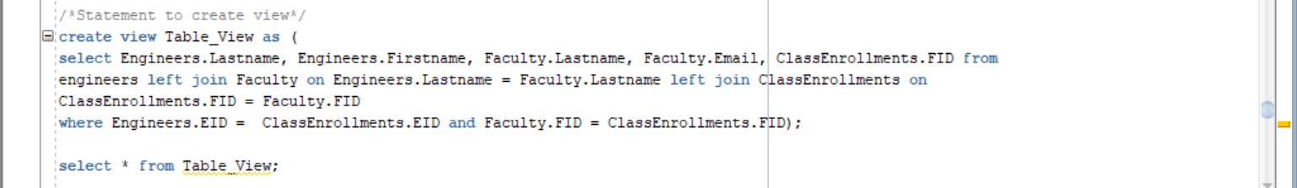

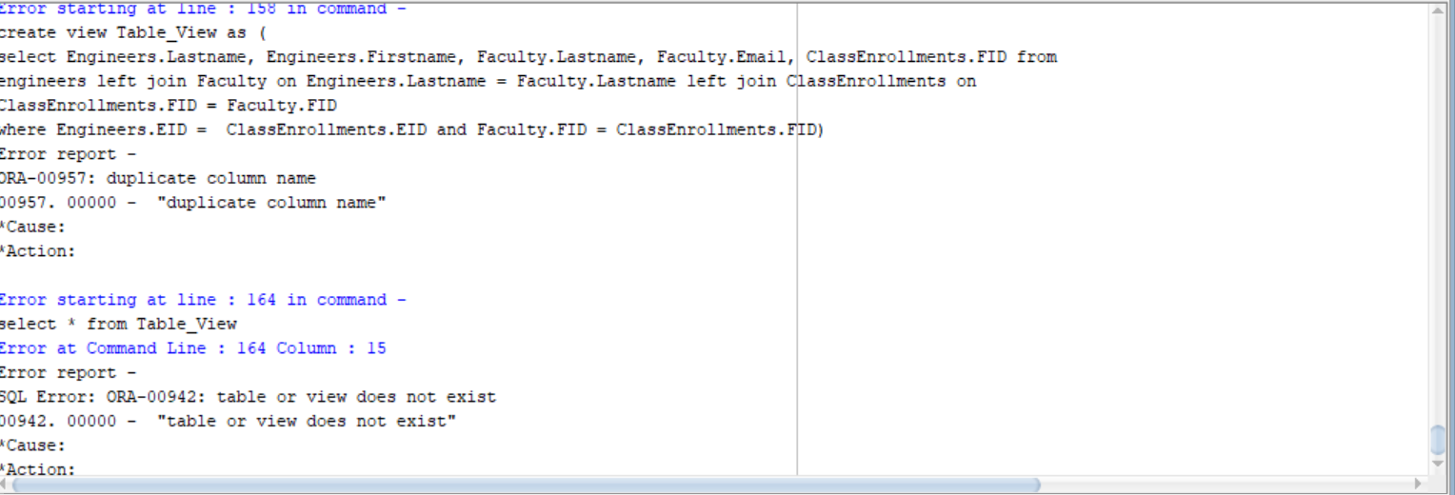

Figures 10a, 10b: Creating a View.

The only step of the program to fail. The above attempt to create a view returned errors of duplicate columns and nonexistent views.